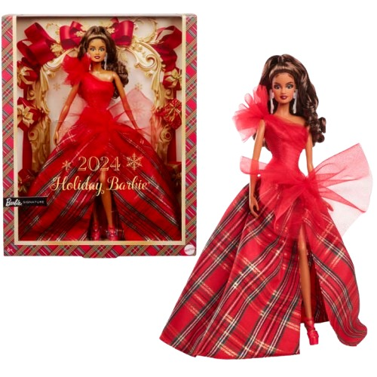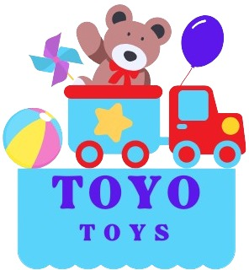

**Holiday Barbie**

**Price: $19.99**

**Celebrate the magic of the holidays with style**

**A keepsake to cherish for years to come The Holiday Barbie is a timeless classic that embodies the spirit of the season. With her sparkling gown and festive charm, she’s the perfect gift for creating lasting memories forever and girl love to play with it**

.

**Product details**

**THANK YOU!**

**WELLCOME TO OUR WEBSITE**